
National Interscholastic Swimming Coaches Association
2008-2009 All-America Team
Muncie Central High School

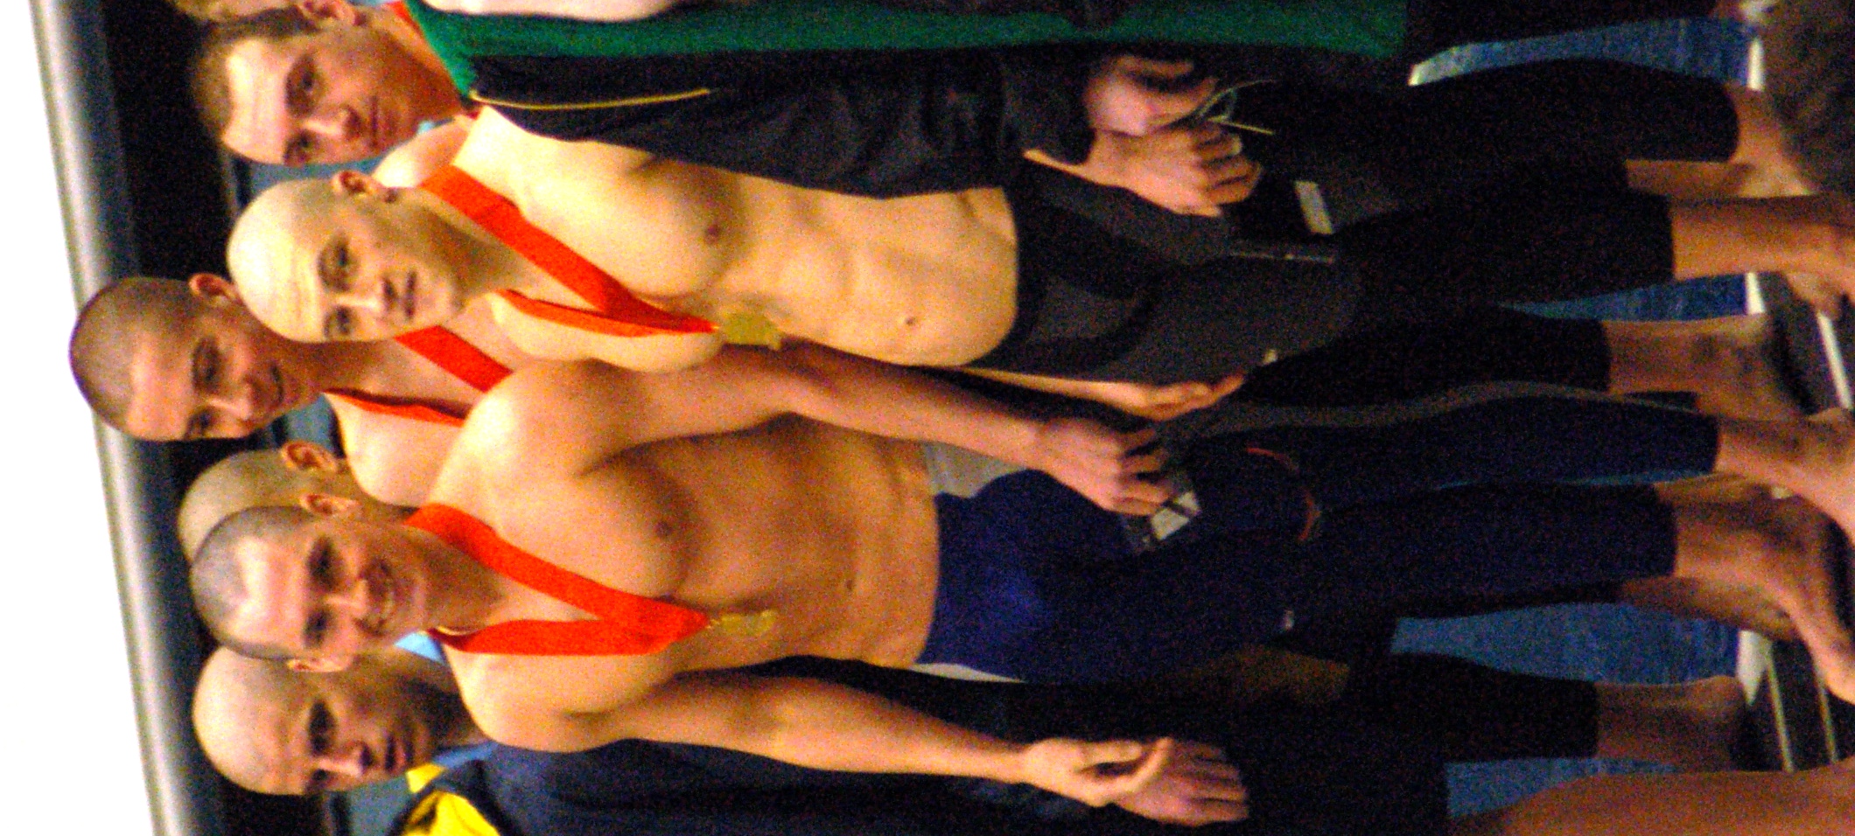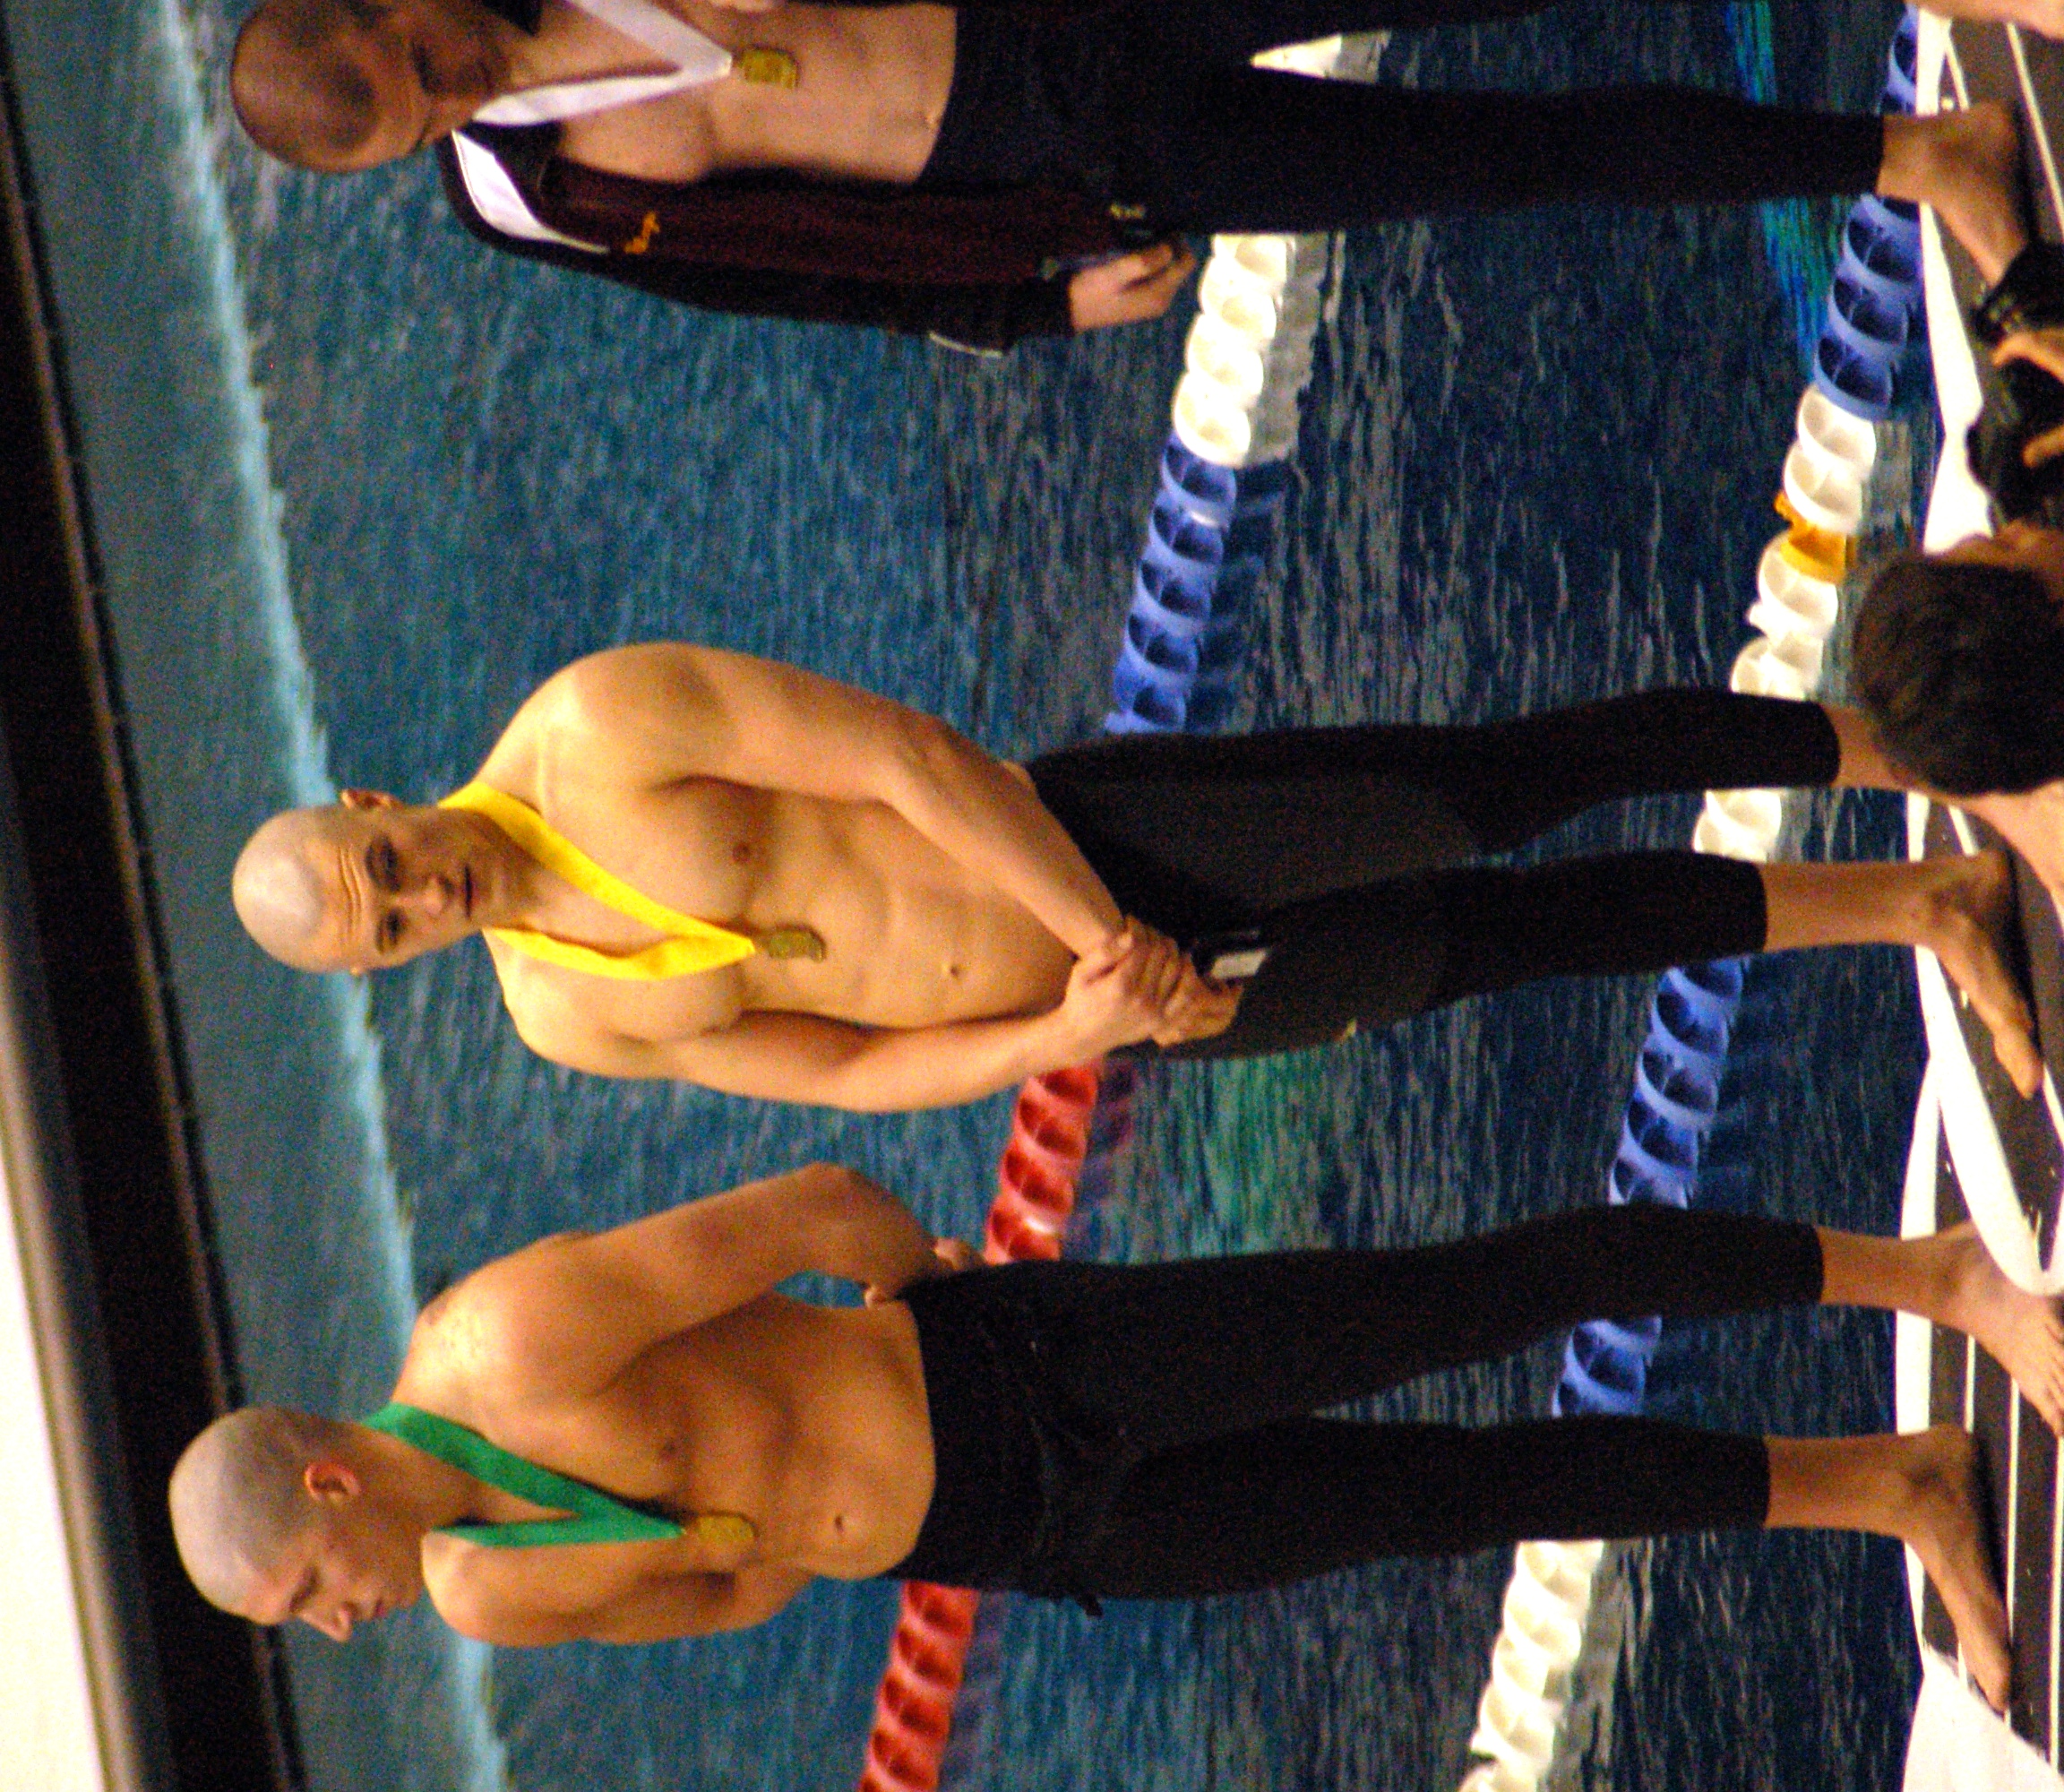
200 Medley Relay – 6th Place- 50 Yard Freestyle – 4th
1:36. 20 Prelim 21.16
1:36.41 Finals Prelim & Finals
Mitch Parmerlee, Devon Hill Devon Hill
Tim Miller, Daniel Proctor

